

Getting Started | Onboarding Overview

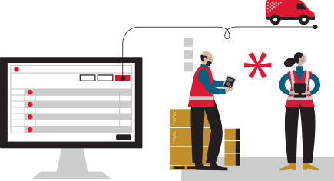

Welcome to RyderShip!

Following the Getting Started & FAQ section, this guide follows the RyderShip Navigation bar to explore features, with links to helpful resources in the Help Center.

Table of Contents

- Getting Started – FAQ & Support (Page 3)
- Orders – Management, Statuses, & Types (Page 4)
- Processing Order Options – Options for Editing Orders (Page 5)
- Items & Inventory – Item Creation, Classification, Filters & Updates (Page 6)
- Ship Notices – Requirements, Publishing & Inspection (Page 7)
- Returns & Exchanges – Policies, Processing & Best Practices (Page 8)
- Searches & Filters – Filtered & Saved Search Options (Page 9)
- Shipping Methods & Mapping – Methods, Mapping & Preferences (Page 10)
- Preferences & Settings – Account Settings, Rules & Notifications (Page 11)
- Insights & Data – Performance Metrics & Data (Page 12)

Getting Started

- Transferring Inventory
- Creating a Ship Notice
- Preparing Products
- Timelines & Service Levels
- RyderShip Help Center
- Contacting Support

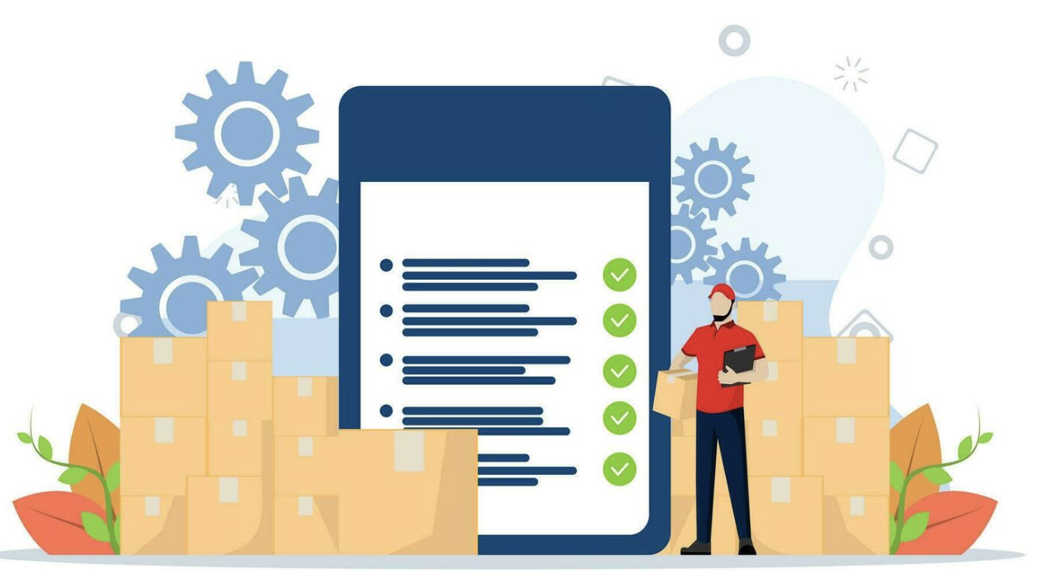

Orders

To process an order, we need the following information: the recipient's name and address, the items being ordered, the quantity of each item, and the chosen shipping method.
- Orders Overview
- Order Status
- Order Types
- Pre-Order vs Insufficient Inventory (Out of Stock)
- Wholesale Orders
- Order Filter Options

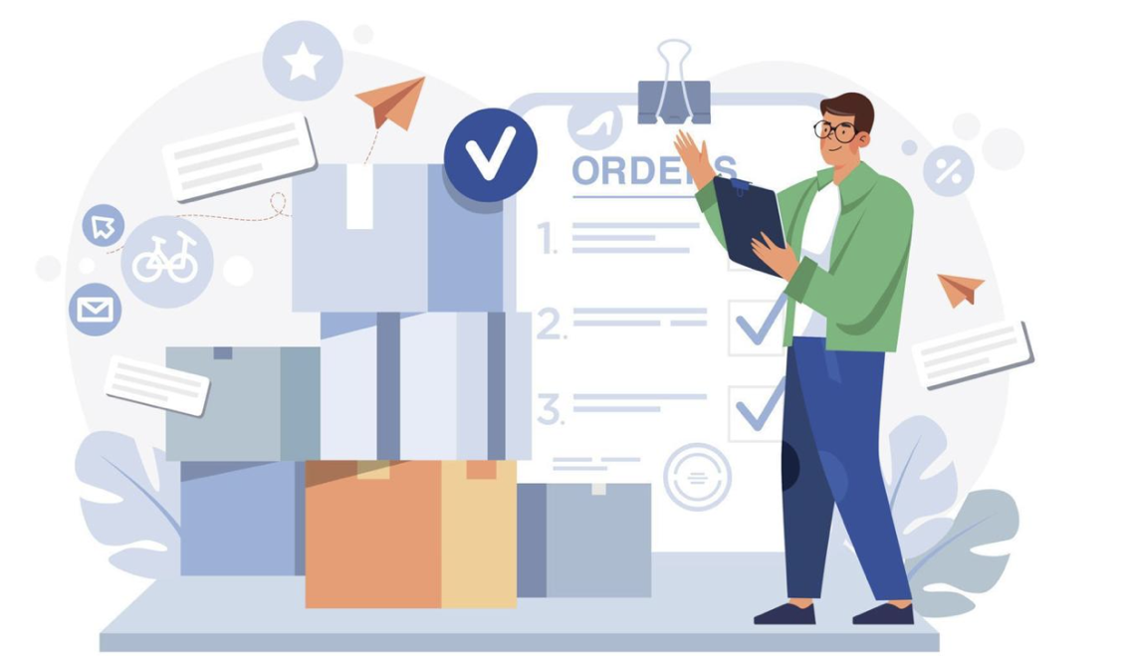

Processing Order Options

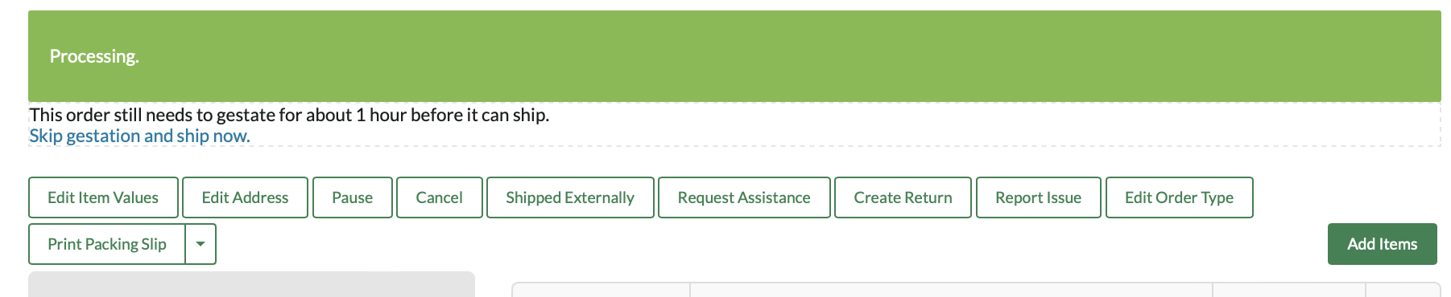
- Edit Item Values
- Edit Address
- Pause/Release
- Cancel/Un-cancel
- Shipped Externally
- Create Return
- Report Issue
- Edit Order Type
- Print Packing Slip
- Add Items
- Skip Gestation

Items & Inventory
- Creating Items
- Item Classification
- Promotional Items/Inserts
- Managing SKU's
- Updating Inventory Properties
- Inventory Filter Options
- Inventory Snapshots
- Prohibited & Restricted Items

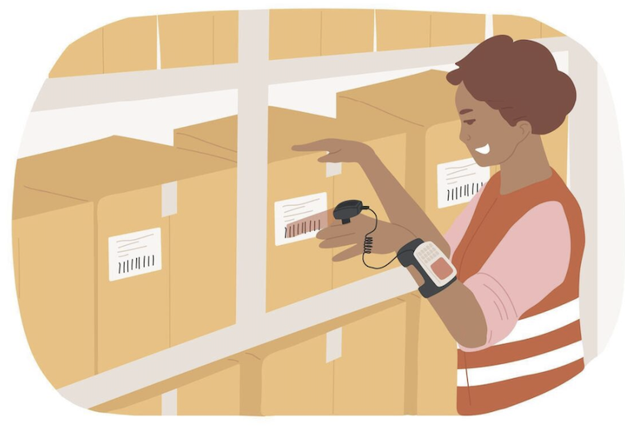

Ship Notices

Each time you send inventory to one of our facilities, you must create a Ship Notice. The Ship Notice is an advance notification, detailing the items and quantities expected. When your shipment arrives, we'll compare the contents against your Ship Notice and provide a report showing what was received.
You’ll receive a unique Ship Notice ID when creating a Ship Notice. This ID must be attached clearly to the cartons in your shipment to avoid delays during receiving. It is best practice to include tracking numbers on your inbound Ship Notice.
You can create and track Ship Notices by selecting Ship Notices in the top navigation bar.
- Ship Notices Overview
- Requesting a Ship Notice Inspection
- Ship Notice Publishing

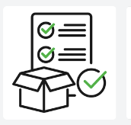
Returns & Exchanges

- Returns & Exchanges Overview
- Customer Initiated Returns
- Return Considerations
- Returns Processing
- Returns Notification & System Update
- International Returns

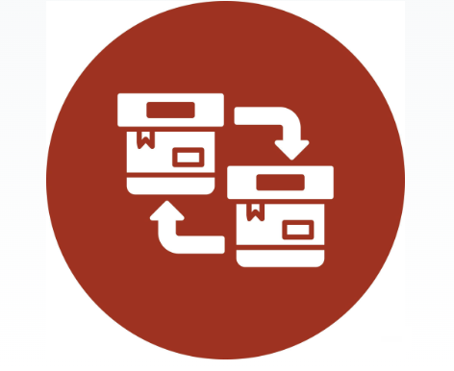

Searches & Filters

Search Filters allow you to work with smaller cohorts of orders, items, shipments, returns, and more.

- Using Filtered Search Options
- Saved Search Options
- Inventory Filter Options
- Order Filter Options

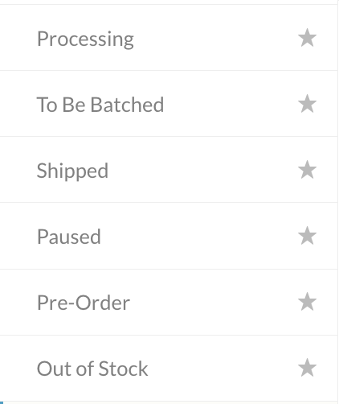

Shipping Methods & Mapping

- Shipping Method Preferences
- Shipping Method Mapping
- International Shipping

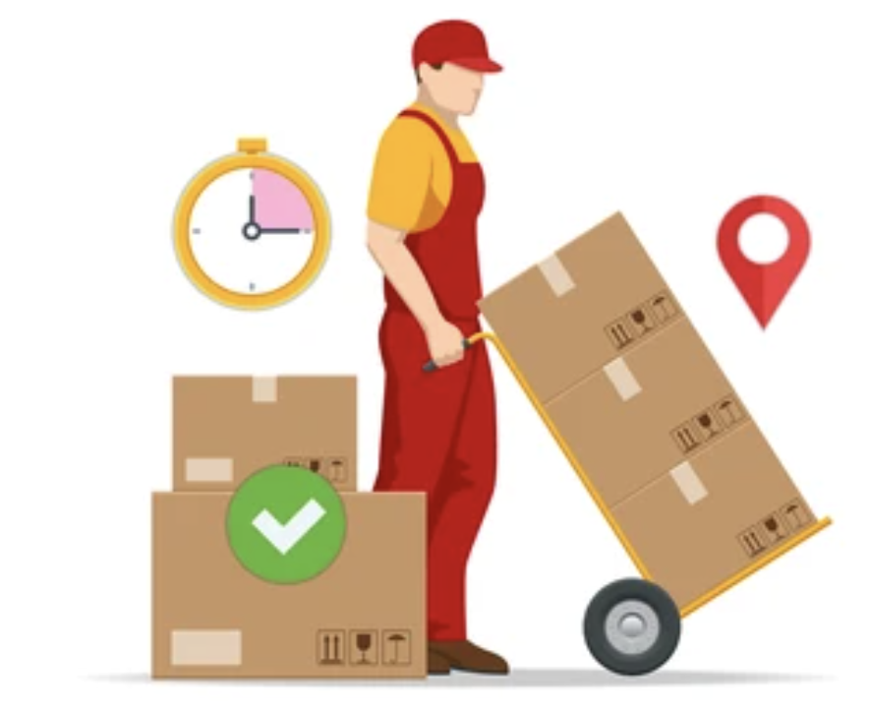

Preferences & Settings
Account Level
- Order Gestation
- Packing Slips & Templates
- Email Confirmations
- Lot Control Settings

Rules
- Packing Rules
- Routing Rules
- Adjusting Rules

Notifications
- Notification Descriptions
- Inventory Notifications
- Order Notifications
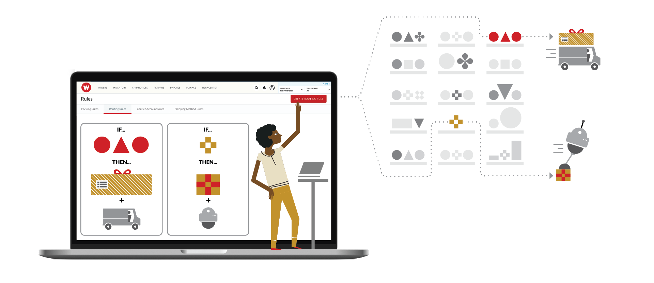

Insights & Data
RyderShip Insights offers an intuitive and dynamic dashboard showcasing your key performance metrics. View live order and shipping information, historical transaction data, and long-term trends.

Insights
- RyderShip Insights
- RyderShip Parcel Insights

Data
- Your Files
- Inventory Snapshots

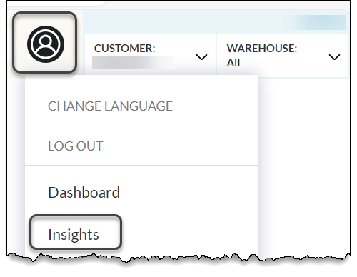

Thank You!

